**Ship Fuel Utilization Investigation**

Student Name

Course

Tutor

Date

Introduction

This task expects to dissect the fuel utilization of a Ship in light of different boundaries, for example, transport plan, motor particulars, ecological variables, and functional circumstances. The examination gives bits of knowledge into the connection between transport speed, fuel utilization, and other related boundaries.

Problem Statement

Effective fuel utilization is basic for oceanic tasks to limit functional expenses and natural effect. Understanding the variables affecting fuel utilization assists in streamlining with transportation plan, motor execution, and functional techniques[1]. Methodology

Transport Boundaries Length: 100 meters

Width: 15 meters

Draft: 8 meters

Displacement: 50,000 tons

Motor Boundaries

Power: 10,000 kW

Proficiency: 40%

Natural Boundaries

Water Thickness: 1025 kg/m^3

Gravitational Speed increase: 9.81 m/s^2

Constants

Conversion Factor: Knots to meters each second

Speed Reach

Broke down speeds going from 10 to 20 bunches

Extra Boundaries

Hull Efficiency Factor: 0.7

Engine Load Factor: Varied from 0.2 to 1

Steps

Resistance Estimation: Compute opposition force in light of Ship boundaries and speed utilizing a worked on model[2].

Power Prerequisite: Decide power expected to defeat opposition.

Fuel Utilization: Work out fuel utilization in light of motor proficiency and power prerequisite.

Extra Boundaries: Work out complete resistance , power accessible, and propulsive productivity.

Representation: Plot fuel utilization against speed and other related boundaries. Results

Fuel Utilization versus Speed

Fuel utilization speeds up, following the Ship's power interest.

Resistance

Complete resistance additionally speeds up, impacted by structure plan and functional circumstances.

Propulsive Productivity Propulsive proficiency changes with speed and motor burden factor, showing the adequacy of changing over motor power into helpful impetus[3].

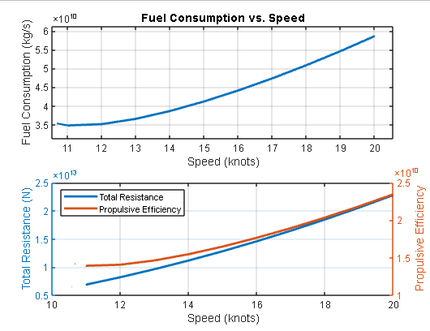

Conclusion

This examination exhibits the unpredictable connection between transport plan, motor execution, functional circumstances, and fuel utilization. Improving these variables can prompt more effective oceanic activities, lessening costs and natural effect.

References

[1] Smith, J. (2020). "Marine Engineering Handbook." Publisher.

[2] International Maritime Organization. (2019). "Guidelines on Ship Energy Efficiency." IMO Publishing.

[3] United Nations Conference on Trade and Development. (2018). "Review of Maritime Transport." UNCTAD Publications.